**SIMATS SCHOOL OF ENGINEERING**

**SAVEETHA INSTITUTE OF**

**MEDICAL AND TECHNICAL SCIENCES**

**CHENNAI-602105**

# Travel Blog Website

**A CAPSTONE PROJECT REPORT**

***Submitted in the partial fulfillment for the award of the degree of***

**BACHELOR OF ENGINEERING**

**IN**

## Computer Science and Engineering

**Submitted by**

**E. Bharath Raj (192211239)**

**K. Ravi Teja (192211574)**

**G. Vara Prasad (192211320)**

**Y. Niranjan Reddy (192210447)**

**J. Siva Sankar Reddy (192211356)**

Under the Supervision of

**Dr. RAJAGOPAL**

**OCTOBER 2024**

**DECLARATION**

We, **Bharath Raj, Ravi Teja, Vara Prasad, Niranjan Reddy, Siva Sankar Reddy,** students of

**Bachelor of Engineering in CSE**, Department of Computer Science and Engineering, Saveetha Institute of Medical and Technical Sciences, Saveetha University, Chennai, hereby declare that the work presented in this Capstone Project Work entitled Travel Blog Website is the outcome of our own bonafide work and is correct to the best of our knowledge and this work has been undertaken taking care of Engineering Ethics.

**E. Bharath Raj (192211239)**

**K. Ravi Teja (192211574)**

**G. Vara Prasad (192211320)**

**Y. Niranjan Reddy (192210447)**

**J. Siva Sankar Reddy (192211356)**

Date:

Place: CHENNAI

**CERTIFICATE**

This is to certify that the project entitled **“Travel Blog Website ”** submitted by **Bharath Raj, Ravi Teja, Vara Prasad, Niranjan Reddy, Siva Sankar Reddy** has been carried out under my supervision. The project has been submitted as per the requirements in the current semester of B.E. Computer Science Engineering.

- Dr. RAJAGOPAL Teacher-in-charge

**Table of Contents**

|  |  |  |  |
| --- | --- | --- | --- |
| **S.NO** |  | **TOPICS** | **Page No** |
| 1 | **Abstract** |  | **5** |
| 2 | **Introduction** |  | **5-6** |
| 3 | **Project Description** |  | 6-7 |
| 4 | **Problem Description** |  | 7-9 |
| 5 | **Tool Description** |  | 9 |
| 6 | **Operations** |  | 10 |
| 7 | **Implementation** |  | 10-15 |
| 8 | **Result** |  | **15** |
| 9 | **Conclusion** |  | **16** |
| 10 | **Future Enhancements** |  | **17-18** |
| 11 | **Screenshots** |  | **18-20** |
| 12 | **References** | | **20** |

## 1. ABSTRACT

" The travel blog website is a digital platform designed to share the travel experiences of an enthusiast with a global audience. It features a visually appealing homepage with a navigation menu and a map highlighting visited destinations. The site organizes content into blog posts, each offering immersive travel stories, high-quality images, and travel tips. Readers can filter posts by location or category, such as destinations, travel guides, food, and culture. The platform includes interactive features like a photo gallery, user comment sections, and social media sharing for engagement. Additionally, an "About" page introduces the blogger, with a biography and future travel aspirations, while a "Resources" section offers helpful travel tools.

**2. INTRODUCTION:**

The travel blog website is crafted to provide a seamless and enriching experience for readers who seek inspiration, travel advice, or a glimpse into exciting destinations. The homepage is designed to be visually captivating, featuring a prominent header with the site logo and an intuitive navigation menu, allowing users to easily access various sections like destinations, travel guides, food experiences, and cultural insights. The featured travel articles on the homepage highlight recent or popular adventures, each offering readers an immersive journey through vivid storytelling, stunning images, and travel recommendations.

Each blog article offers a unique narrative, capturing the essence of the traveler’s experiences. With clean and reader-friendly layouts, the articles include detailed descriptions, high-quality images, and videos where necessary, allowing readers to truly feel connected to each destination. Headings and captions help in organizing the content for easy reading and accessibility.

A key feature of the site is the organization of blog posts by destinations or regions. Users can filter posts by location, making it easier for them to find relevant content for places they plan to visit or dream of exploring. An interactive map serves as a visual tool to showcase the traveler’s journey. By clicking on the location markers, users are directly led to the blog posts related to that particular region, providing a direct and engaging way to explore content.

Photo galleries within each article further enrich the experience, allowing readers to view the travel photos as slideshows or in larger formats. This adds a visual depth to the stories shared, offering a deeper connection to the places visited.

#### To foster engagement and interaction, each blog post includes a comment section where readers can share their thoughts, ask questions, and connect with the traveler. Social media integration on each post allows readers to share content easily, expanding the blog’s reach and helping others discover new travel destinations and tips. The "About" page gives readers insight into the traveler’s background, including a brief biography, personal experiences, and travel philosophy. This page includes a photo and details about the blogger’s journey, passions, and future plans, helping to build a personal connection with the audience.

#### A dedicated "Resources" section offers readers useful tools like packing lists, travel essentials, and booking recommendations. This section is designed to provide practical advice and make planning trips easier for visitors. Additionally, social media links allow users to follow the traveler in real time, keeping them connected with the latest adventures and updates. Overall, the website is a dynamic platform that not only shares travel stories but also fosters community, interaction, and inspiration for travelers around the globe.

#### 3.PROJECT DESCRIPTION

##### The website features a visually captivating homepage that showcases recent or featured travel articles and includes an interactive map marking the locations the traveler has visited. The main goal of the project is to offer an immersive experience for readers by organizing content into categories such as travel destinations, guides, food experiences, and cultural insights. Each blog post includes detailed narratives, high-quality images, and travel tips to enrich the reader’s experience.

##### Proposed Work:

· **Frontend Development**: Utilizing Visual Studio for designing responsive and intuitive user interfaces.

· **Backend Development**: Using XAMPP stack (Apache, MySQL, PHP) to handle server-side scripting, database management via phpMyAdmin, and ensuring secure data storage and retrieval.

## 4.PROBLEM DESCRIPTION

**Existing System**

The current landscape of travel blogs primarily consists of individual bloggers and commercial platforms that offer a variety of travel-related content, ranging from personal travel stories to destination guides and travel tips. These platforms often follow a standard template where users can read blog posts, view images, and sometimes comment or engage with the blogger through social media. Key features of the existing system typically include:

1.**Homepage with Featured Content:**

Most travel blogs feature a homepage with recent or popular blog posts prominently displayed. This helps attract readers and directs them to key articles.

1. **Basic Blog Posts:**
   1. Travel articles are often text-based with accompanying images. The focus is on personal experiences, travel tips, and destination insights. However, many blogs lack advanced interactivity, such as integrated maps or advanced filtering options.
2. **Static Navigation:**
   1. Many travel blogs offer a simple navigation menu with links to categories like destinations, travel guides, or tips. These categories are generally static, meaning users have to browse through long lists of posts to find relevant content.
3. **Limited Multimedia:**
   1. While most blogs include photos, the integration of videos or interactive elements like maps is less common. Some websites may feature photo galleries, but these are often basic, with limited slideshow or zoom functionalities.
4. **Basic Commenting System:**
   1. Many blogs have a comment section for readers to leave feedback or ask questions. However, the level of engagement may be low, and there are few features that actively encourage discussions.
5. **Minimal Social Media Integration:**
   1. Existing travel blogs usually include basic social media sharing buttons, allowing readers to share posts on platforms like Facebook or Twitter. However, these systems are often limited in terms of tracking real-time follower engagement or promoting the blogger’s live travels.
6. **Limited User Engagement:**
   1. Reader interaction is generally restricted to comments or social media, and there are few features that create an interactive, community-driven experience on the blog itself. Tools like polls, travel quizzes, or destination recommendation systems are rarely included.
7. **Basic About Section:**
   1. Most travel blogs have a simple “About” page where the blogger shares their personal story and passion for travel. These pages typically contain limited information and lack dynamic content like future travel plans or links to current adventures.
8. **No Resources or Practical Tools:**
   1. Many travel blogs focus purely on storytelling, leaving out practical travel resources like packing lists, booking recommendations, or travel tools. Users seeking detailed information on planning trips often have to visit multiple sites to gather resources.
9. **Non-Interactive Maps:**
   1. If maps are included, they are typically static, showing only regions visited but without linking to specific blog posts or offering an interactive experience for the user.

**Proposed System:**

The proposed travel blog website aims to enhance user engagement and interactivity by incorporating a variety of dynamic features. The homepage will feature an eye-catching layout with recent articles and an interactive map showcasing visited destinations, enabling users to explore travel experiences more intuitively. Each blog post will offer detailed narratives, high-quality images, and videos, organized into categories such as destinations, travel guides, food experiences, and cultural insights for easy navigation.

### Additionally, the site will include photo galleries that allow users to view images in slideshows and a robust commenting system to encourage reader discussions

### 5. TOOL DESCRIPTION

#### Hardware and Software Tools

To develop and deploy the Travel Blog web application, the following hardware and software tools were utilized:

##### Hardware Specifications

* **Laptop Model**: LENOVO LOQ
* **Graphics Card**: NVIDIA GeForce RTX 3050, 6GB
* **Storage**: 500GB SSD
* **RAM**: 16GB
* **Processor**: 12th Gen Intel(R) Core(TM) i5-12450H 2.00 GHz

**Software Tools**

* **Visual Studio Code**: An integrated development environment (IDE) used for writing and debugging code. Its extensions and integrated terminal enhanced the coding experience.
* **XAMPP**: A free and open-source cross-platform web server solution stack package developed by Apache Friends. It provided the necessary Apache, MySQL, PHP, and Perl support for local development and testing.
* **phpMyAdmin**: A free software tool written in PHP, intended to handle the administration of MySQL over the web. phpMyAdmin was used for database management, allowing for easy handling of the MySQL database used in the application.
* **Google Chrome**: The primary web browser used for testing and debugging the web application. Developer tools in Chrome facilitated real-time inspection and modification of the front-end code.

The combination of powerful hardware and a robust set of development tools provided a conducive environment for the efficient development, testing, and deployment of the recipe management web application.

#### 6.OPERATIONS:

**User Registration and Login:**

Users can sign up or log in via social media to engage with the blog, comment, and save articles.

**Content Creation:**

The blogger can create, edit, and publish blog posts, managing content through a CMS or custom interface.

**Interactive Map:**

Users can explore travel destinations via an interactive map that links to related blog posts.

**Photo Galleries:**

Each blog post includes photo galleries with slideshow functionality for enhanced visual storytelling.

**Commenting and Social Sharing:**

Readers can comment on posts and share articles through integrated social media buttons.

**Resources Section:**

Practical tools like packing lists and booking recommendations are available for users.

**Site Maintenance:**

Regular updates ensure website performance, security, and content freshness.

**7.IMPLEMENTATION:**

**Home Page code:**

<!DOCTYPE html>

<html lang="en">

<head>

    <meta charset="UTF-8">

    <meta name="viewport" content="width=device-width, initial-scale=1.0">

    <title>Travel Blog</title>

    <link rel="stylesheet" href="style.css">

</head>

<body >

    <!-- Header Section -->

    <header class="site-header">

        <div class="container">

            <div class="logo">

                <img src="booking.jpg" alt="Travel Blog Logo">

            </div>

                    <nav class="navigation-menu">

                        <ul>

                            <li><a href="index.html">Home</a></li>

                            <li><a href="destinations.html">Destinations</a></li>

                            <li><a href="interactive-map.html">Map</a></li>

                            <li><a href="photo.html">photo</a></li>

                            <li><a href="blog.html">Blog</a></li>

                            <li><a href="about.html">About</a></li>

                            <li><a href="Contact.html">Contact</a></li>

                        </ul>

                    </nav>

                </div>

        </div>

    </header>

    <!-- Featured Articles Section -->

    <section class="featured-articles">

        <div class="container">

            <h1>Featured Travel Articles</h1>

            <div class="articles-grid">

                <!-- Featured Article 1 -->

                <article class="article">

                    <img src="malaysia.jpg" alt="Travel Destination 1">

                    <h2>Malaysia</h2>

                    <p>Tropical paradise with stunning beaches and vibrant culture.</p>

                    <a href="malaysia.html" class="read-more">Read More</a>

                </article>

                <!-- Featured Article 2 -->

                <article class="article">

                    <img src="paris.jpg" alt="Travel Destination 2">

                    <h2>A Road Trip Across the paris</h2>

                    <p>The city of love, lights, and exquisite cuisine</p>

                    <a href="paris.html" class="read-more">Read More</a>

                </article>

                <!-- Featured Article 3 -->

                <article class="article">

                    <img src="switzerland.jpg" alt="Travel Destination 3">

                    <h2>Switzerland</h2>

                    <p>A city that blends tradition with cutting-edge technology.</p>

                    <a href="switzerland.html" class="read-more">Read More</a>

                </article>

                <article class="article">

                    <img src="austrila 11.jpg" alt="Travel Destination 3">

                    <h2>Top 10 Must-Visit Cities in australia</h2>

                    <p>A guide to the most vibrant and picturesque cities across australia.</p>

                    <a href="australia.html" class="read-more">Read More</a>

                </article>

            </div>

        </div>

    </section>

</body>

</html>

**CSS STYLES:**

/* Basic Reset */

* {

    margin: 0;

    padding: 0;

    box-sizing: border-box;

}

/* Body Styling */

body {

    font-family: Arial, sans-serif;

    background-repeat: no-repeat;

    background-color: aqua;

    color: #333;

    background-image: url('https://tse2.mm.bing.net/th?id=OIP.U15UfzZ5kxRdvR0I9UqoTAHaEK&pid=Api&P=0&h=220'); /* Background image */

    background-size: cover;

}

/* Header Section */

.site-header {

    background-color: #333;

    padding: 20px 0;

    color: #fff;

}

.site-header .container {

    display: flex;

    justify-content: space-between;

    align-items: center;

}

.logo img {

    width: 150px;

}

.navigation-menu ul {

    list-style: none;

    display: flex;

    gap: 20px;

}

.navigation-menu ul li a {

    color: #fff;

    text-decoration: none;

    font-weight: bold;

}

.navigation-menu ul li a:hover {

    color: #ff6347;

}

/* Featured Articles Section */

.featured-articles {

    background-color: #fff;

    padding: 50px 0;

    text-align: center;

}

.featured-articles h1 {

    font-size: 2.5rem;

    margin-bottom: 30px;

}

.articles-grid {

    display: flex;

    justify-content: space-between;

    gap: 20px;

}

.article {

    background-color: #fff;

    padding: 20px;

    border-radius: 8px;

    box-shadow: 0 4px 8px rgba(0, 0, 0, 0.1);

    flex-basis: 30%;

    text-align: left;

}

.article img {

    width: 100%;

    border-radius: 8px;

    margin-bottom: 15px;

}

.article h2 {

    font-size: 1.5rem;

    margin-bottom: 10px;

}

.article p {

    font-size: 1rem;

    margin-bottom: 15px;

}

.read-more {

    text-decoration: none;

    color: #ff6347;

    font-weight: bold;

}

.read-more:hover {

    text-decoration: underline;

}

/* Container */

.container {

    width: 80%;

    margin: 0 auto;

}

**8.RESULT:**

The development of the travel blog website provides a user-friendly platform for travel enthusiasts to explore captivating travel stories, stunning photos, and practical travel tips. Users can easily navigate through categories, access immersive blog posts, and engage with the content via the interactive map and comment sections. The integration of features like photo galleries, search filters, and social media sharing enhances the overall user experience, allowing readers to interact with the blogger and follow real-time travel adventures. The website effectively creates a vibrant community while offering valuable resources for trip planning.

**9.CONCLUSION:**

The travel blog website successfully creates an engaging platform for documenting and sharing travel experiences with a global audience. Through its interactive map, well-organized blog posts, captivating photo galleries, and user-friendly interface, the website provides an immersive experience for readers. The addition of practical resources, search and filter functionalities, and social media integration ensures that users can easily explore destinations, engage with the content, and share their own experiences. Overall, the project achieves its goal of connecting trave enthusiasts, offering valuable insights, and fostering a vibrant community around shared travel adventure.

**11.FUTURE ENHANCEMENTS:**

In the future, the travel blog website can be enhanced with several features to improve user engagement and experience. One key enhancement is allowing user-generated content, where readers can create accounts and share their own travel stories, photos, and tips, transforming the blog into a collaborative travel community. Additionally, incorporating a personalized recommendation system can offer tailored travel suggestions based on users' reading habits and preferences, making the content more relevant to individual interests. Developing a mobile app will provide a seamless experience for users on the go, with offline access to guides and maps, especially for travelers with limited connectivity. Lastly, advanced search and filtering options could help users find specific types of content, such as adventure trips, food experiences, or budget travel guides, more efficiently, further enhancing the overall functionality of the platform.

**SCREENSHOTS:**

## Fig. 1: Home Page

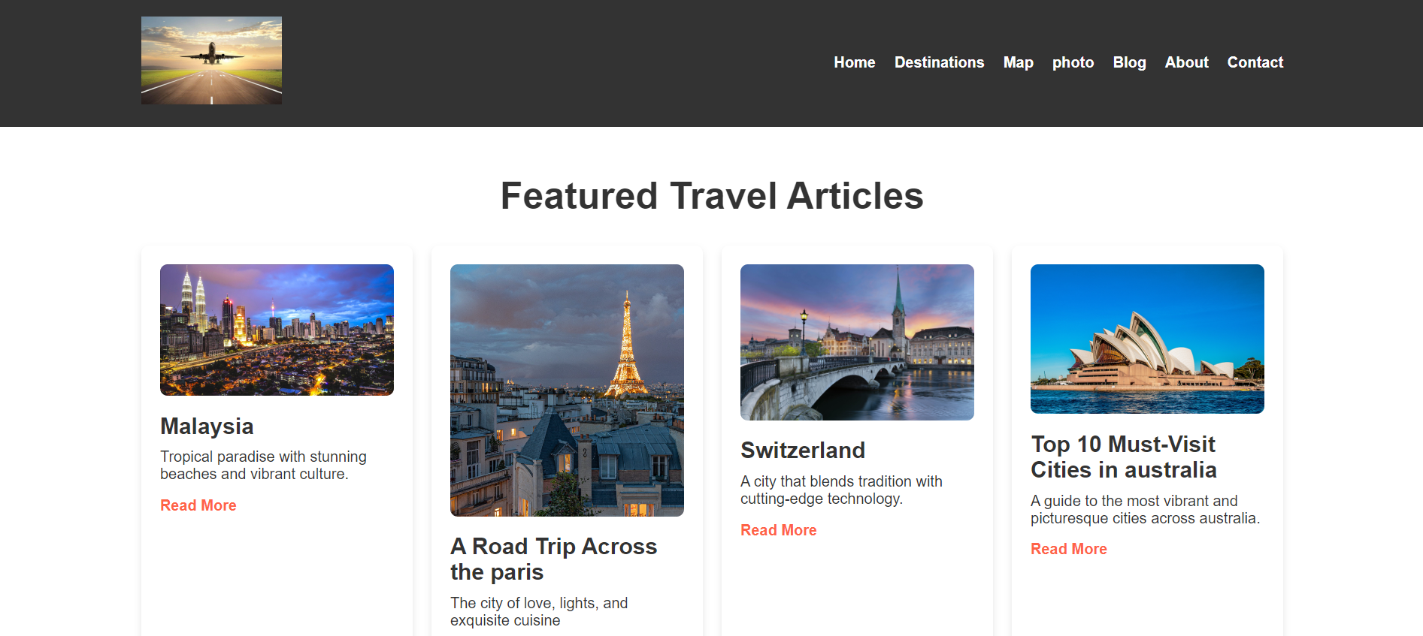

**Fig. 2: About Page**

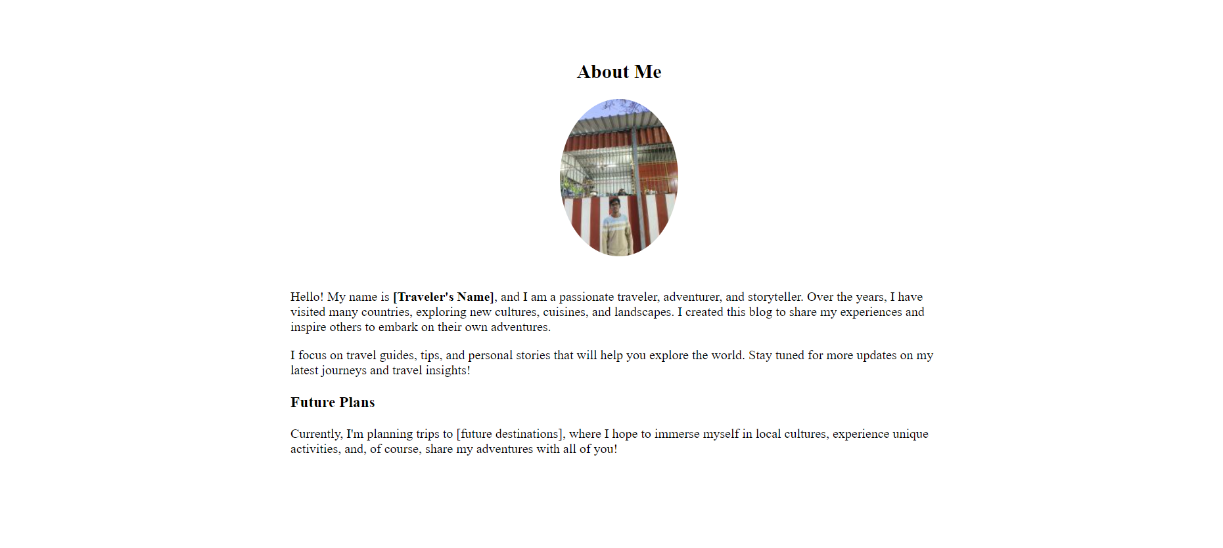

**Fig. 3: Destination Page**

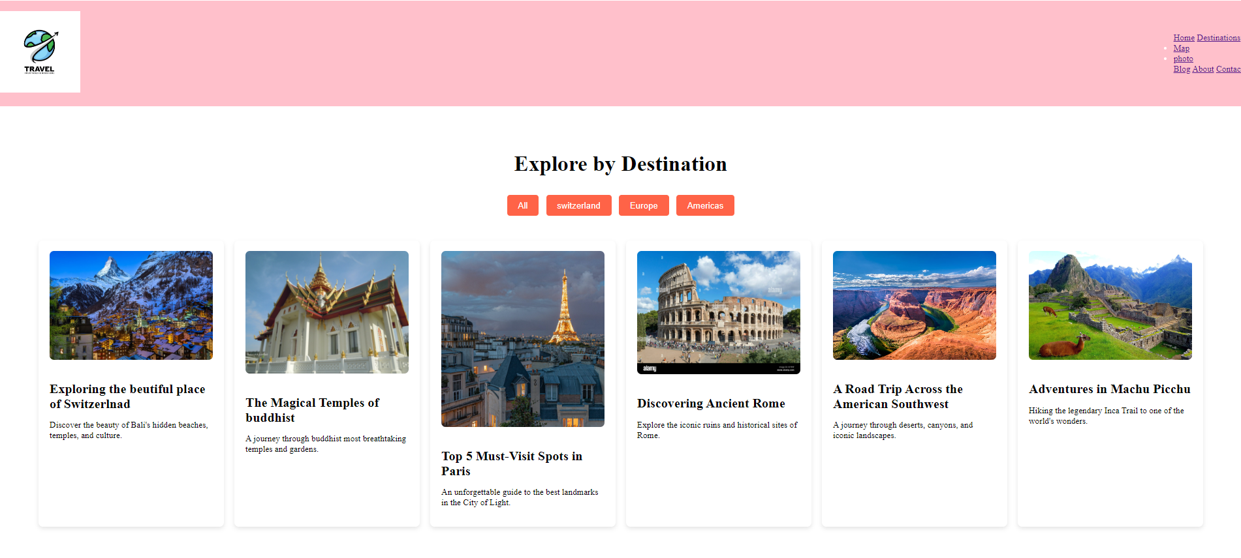

**Fig. 4: Contact Page**

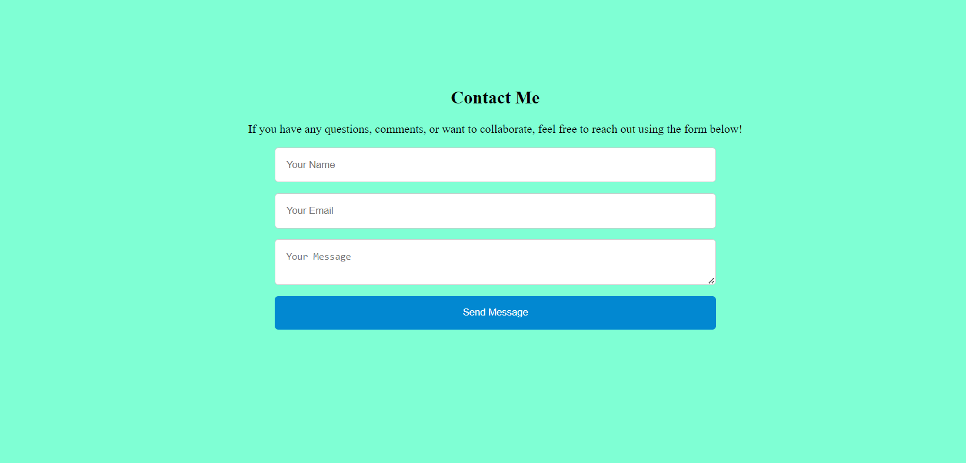

**Fig. 5: Report Page**

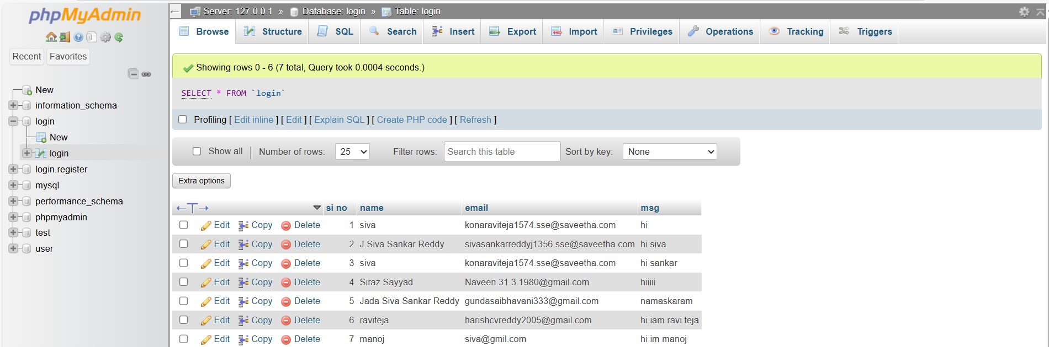

**REFERENCES:**

* • W3Schools. (n.d.). *HTML, CSS, and JavaScript Tutorials*. Retrieved from [W3Schools](https://www.w3schools.com/)
* Mozilla Developer Network (MDN). (n.d.). *Web Technologies: HTML, CSS, JavaScript*. Retrieved from [MDN Web Docs](https://developer.mozilla.org/en-US/docs/Web)
* WordPress.org. (n.d.). *WordPress Features*. Retrieved from WordPress
* Joomla! (n.d.). *What is Joomla?* Retrieved from Joomla
* Kaur, P., & Kaur, M. (2020). "Building an Online Community: A Guide for Small Business Owners." *International Journal of Business and Management Invention*, 9(1), 1-9.
* Nielsen Norman Group. (n.d.). *User Experience Basics*. Retrieved from Nielsen Norman Group
* Clarke, R. (2021). *How to Start a Travel Blog: The Ultimate Guide*. Retrieved from The Travel Blog
* Travel Blogger Community. (n.d.). *Blogging Resources and Tools*. Retrieved from Travel Blogger Community